**➤ Project - Java EE**

|  |  |  |  |  |
| --- | --- | --- | --- | --- |
| ***Team*** | ***Author*** | ***Date*** | ***Description*** | ***Publish Version*** |
| **Dev_Team** | **Nguyen Tri Quang** | **Start: 01/08/2022** | **Initial version** | **1.0** |
|  | **Dang Van Tue Tran Phuc Tuyen** |  | **Project-Java** |  |
|  | **Vo Khanh Loc Giang Tan Phuc** | **End: 00/00/2022** | **Amazon Book Store** |  |

# **Overview setup Project Local:**

This document is guiding how to setup Project Local.

Requirement:

1. [Spring Tools 4 or Eclipse](https://spring.io/tools)
2. Install [MySQL Workbench](https://dev.mysql.com/downloads/windows/installer/8.0.html) . You can watch the detailed installation instruction video. [Click here](https://www.youtube.com/watch?v=YSOY_NyOg40)
3. Install and Setup Lombok in Spring Tool Suite IDE. You can refer to the video tutorial. [Click here.](https://www.youtube.com/watch?v=VR7VaiXHJEY&t=558s)
4. GitHub for repositories
5. Download maven package: <https://dlcdn.apache.org/maven/maven-3/3.8.6/binaries/apache-maven-3.8.6-bin.zip>
6. Source Code

Link to clone source code: <https://github.com/triquang15/Books-Amazon.com>

Clone success, remember to switch to branch dev_team

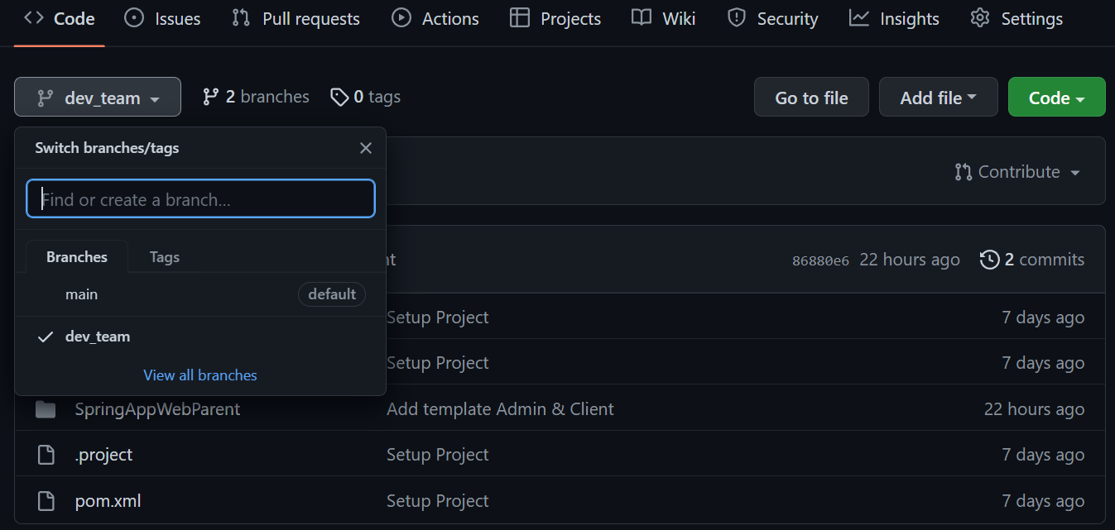

* Import the project into Spring Tool -> Run.
* Admin:  [http://localhost:8080/Admin](%20%20%20http:/localhost:8080/Admin)
* Client: <http://localhost/Client>

1. Project Overview

- Spring framework development with Spring Boot

- Spring Boot Internationalization (i18n)

- Spring Data JPA and Hibernate framework

- Spring Security for authentication and authorization

- Spring OAuth for social login with Facebook and Google

- Spring Mail for sending customer registration confirmation and order confirmation

- PayPal Checkout API for capturing payment from customer

- Google Chart API for drawing charts of sales report

- JUnit, AssertJ and Mockito in unit testing

- Spring RESTful Webservices

- Bootstrap 5, HTML5 and jQuery 3

- Amazon S3 APIs

- Deployment on Heroku (AWS)+

1. Database

You can see the attached file below

